

POLITICS AND LAW SAMPLE EXAMINATION

STAGE 2

Section 7 of the New WACE Manual: General Information 2006–2009 outlines the policy on WACE examinations.

Further information about the WACE Examinations policy can be accessed from the Curriculum Council website at http://newwace.curriculum.wa.edu.au/pages/about_wace_manual.asp.

The purpose for providing a sample examination is to provide teachers with an example of how the course will be examined. Further finetuning will be made to this sample in 2008 by the examination panel following consultation with teachers, measurement specialists and advice from the Assessment, Review and Moderation (ARM) panel.

0000.doc




Western Australian Certificate of Education, Sample External Examination

Question/Answer Booklet

POLITICS AND LAW
Please place your student identification label in this box
WRITTEN PAPER
STAGE 2

Student Number: In figures

In words

Time allowed for this paper
Reading time before commencing work: Ten minutes
Working time for paper: Three hours

Material required/recommended for this paper

To be provided by the supervisor
This Question/Answer Booklet

To be provided by the candidate
Standard items: Pens, pencils, eraser or correction fluid, ruler, highlighter

Important note to candidates
No other items may be taken into the examination room. It is your responsibility to ensure that you do not have any unauthorised notes or other items of a non-personal nature in the examination room. If you have any unauthorised material with you, hand it to the supervisor before reading any further.

Structure of this paper

Section | Suggested working time | Number of questions available | Number of questions to be attempted | Marks
One:  Short answers | 60 minutes | 6 | 4 | 40 (40%)
Two:  Source analysis | 60 minutes | 2 | 2 | 40 (40%)
Three:  Essays | 60 minutes | 4 | 1 | 20 (20%)
 |  |  | [Total marks] | 100

Instructions to candidates
The rules for the conduct of Curriculum Council examinations are detailed in the Student Information Handbook. Sitting this examination implies that you agree to abide by these rules.

SECTION ONE: SHORT ANSWERS

In this section there are SIX (6) questions. Answer FOUR (4) questions only. Each question is worth 10 marks.

Allow approximately 60 minutes for this section [40 marks].

Question 1
- What is a representative democracy?
[2 marks]

- Outline THREE key features of the Westminster system
[3 marks]

- Briefly explain two constitutional differences between the Senate and the House of Representatives.
[5 marks]

Question 2
- What is meant by a ‘Superior Court’?
[2 marks]

- Outline three differences between common law and statute law.
[3 marks]

- Briefly explain the extent to which judges are bound by precedent.
[5 marks]

Question 3
- What is a citizen?
[2 marks]

- Briefly explain a key external influence on the Australian political and legal system.
[3 marks]

- Assess the impact on a group or individual of a decision by an Australian court or a law made by an Australian parliament.
[5 marks]

Question 4
- What is a constitution?
[2 marks]

- Outline the THREE arms (branches) of government.
[3 marks]

- Briefly explain the extent to which the Australian judicial system reflects the rule of law.
[5 marks]

Question 5
- What is a minor party?
[2 marks]

- Outline three strategies used by a minor party to achieve its aims.
[3 marks]

- Briefly explain the extent to which a minor party has influence in the Australian political and legal system.
[5 marks]

Question 6
- What is meant by natural justice?
[2 marks]

- Outline three reasons why there are alternative political and legal systems.
[3 marks]

(c) Assess one strength or one weakness of Western Australia’s justice system
[5 marks]

END OF SECTION ONE

SECTION TWO: SOURCE ANALYSIS

In this section there are TWO (2) document sets. There are TWO (2) questions. Answer BOTH questions. Each question is worth 20 marks.

Allow approximately 60 minutes for this section [40 marks].

Read the document below and answer the questions that follow

Document Set One
Source 1

In the case of Carr (1988) 62 ALJR 568 (on appeal)

For copyright reasons this text cannot be reproduced in the online version of this document.
In this case, the accused had been convicted on a charge of robbery with violence. The main evidence against him was a typewritten record of interview compiled by three police officers. The evidence of the three police officers was that Carr had fully admitted his guilt, but had refused to sign the record of that confession. In his evidence at the trial, Carr denied that he had committed the robbery and said that he had not made an admission.

Another police officer stated that he knew Carr and that he had seen him in the vicinity of the robbery shortly before it was committed. The description given by the police officer of the clothes Carr was wearing, however, was quite different from that given by other witnesses who saw the offender. A taxi-driver admitted to driving the offender away from the crime, but at the trial he said he had never seen the accused before.

Carr applied for special leave to appeal because he claimed that the judge in the trial should have warned the jury that, when there was a dispute about a confession, caution should be taken before convicting on that evidence. A warning was not given to the jury.

The majority of judges in the appeal to the High Court in this case agreed that the judge in the original case should have given a warning to the jury and, as this has not been done, there had been a miscarriage of justice. As the miscarriage was not because of the evidence put forward in the case, but rather because a warning was not given to the jury, the appellate court could not change the jury verdict to ‘not guilty’. Instead the High Court ordered a retrial.
[From: Beazer, 2004]

With reference to Document Set One answer the following questions.

Question 7
- What was Carr charged with and what was the main evidence against him?
[3 marks]

- Explain the term 'miscarriage of justice'.
[2 marks]

- What was the role of the judge in this case?
[2 marks]

- Describe the type of evidence brought against Carr.
[3 marks]

- What was the basis of the appeal to the High Court by Carr?
[2 marks]

- What was the outcome of the appeal and why?
[3 marks]

- To what extent was justice achieved for Carr in this case?
[5 marks]

Read the documents below and answer the questions that follow

Document Set Two
Source 1

For copyright reasons this text cannot be reproduced in the online version of this document but may be viewed at http://www.newspoll.com.au/cgi-bin/polling/display_poll_data.pl
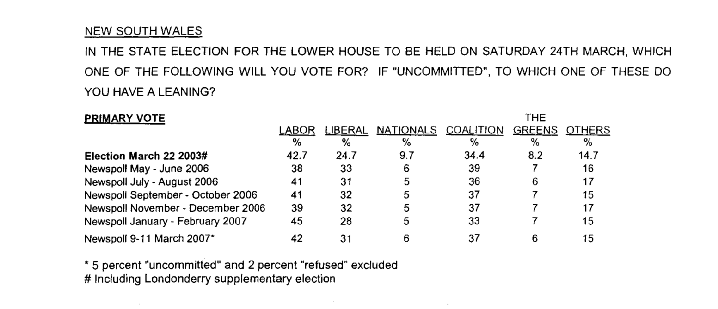

[From: Newspoll & The Australian, 2007]

Source2
Results of the N.S.W. election held on 24 March 2007
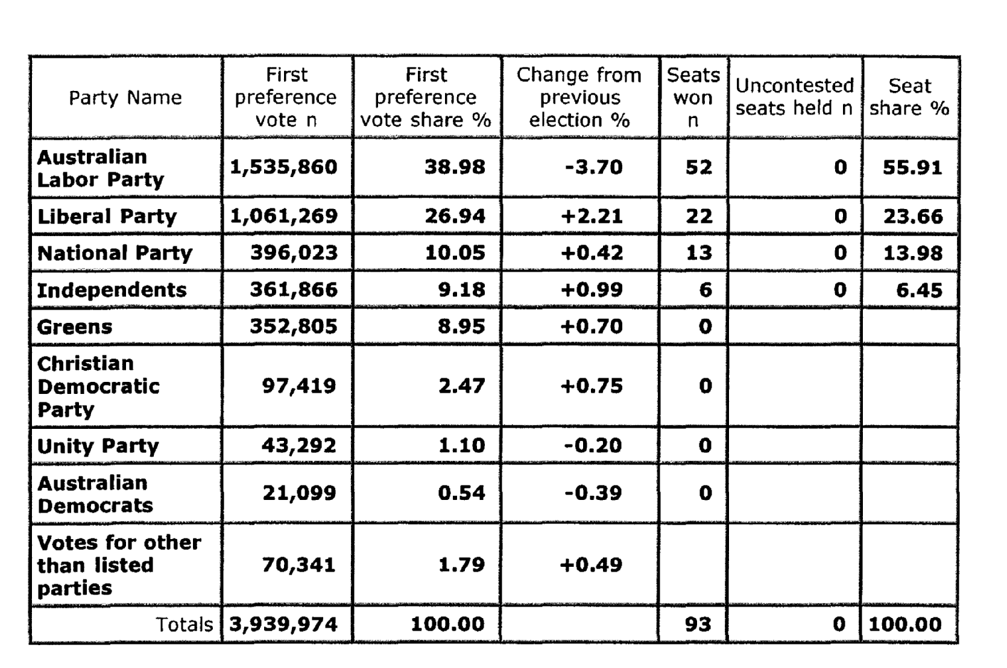

[From: University of Western Australia, 2007]
Source 3
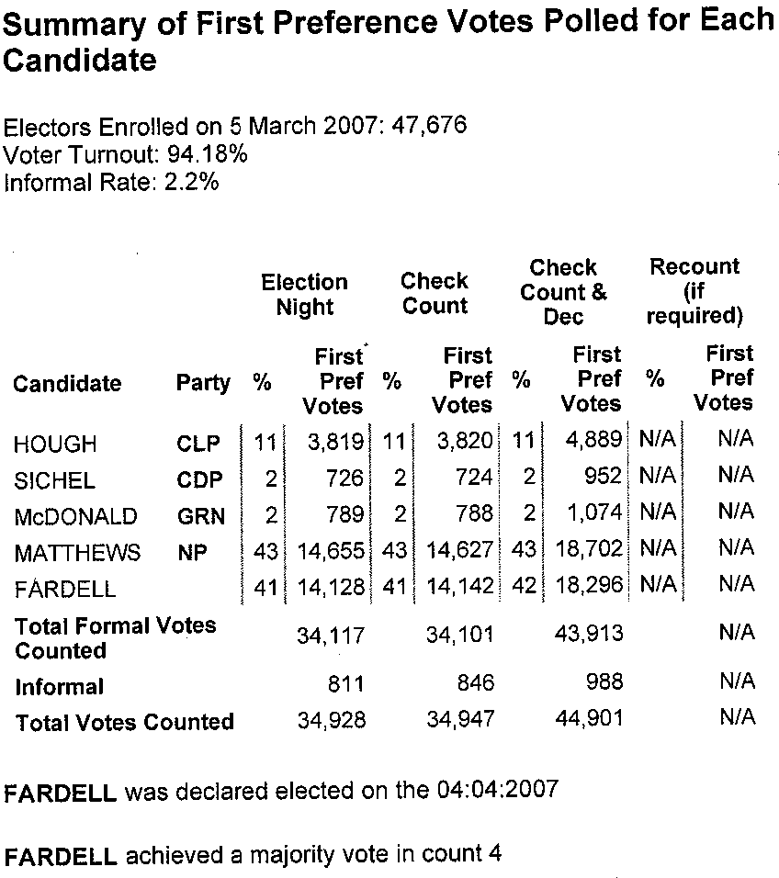

[From: New South Wales Electoral Commission, 2007]

With reference to Document Set Two answer the following questions.

Question 8
- In Source 1, what election outcome is suggested by Newspoll? Explain you reasons.
[2 marks]

- With reference to Source 2, describe the actual election results. [3 marks]

- To what extent is the Newspoll prediction in Source 1 reflected in the election result in Source 2? Explain. [4 marks]

- Refer to source 3 and analyse the voting and the result in Dubbo. [5 marks]

- With reference to the sources and your own knowledge of elections, comment on the ways that citizens can participate in electoral processes in Australia.
6 marks]

END OF SECTION TWO

SECTION THREE: ESSAY

In this section there are FOUR questions. Answer ONE question only.

Allow approximately 60 minutes for this section [20 marks].

Question 9
Discuss the development of the franchise in Australia since Federation and how it currently reflects democratic principles.
[20 marks]

OR

Question 10
'In the Australian legal system parliaments are the primary law makers, but the courts also have a law making role.' Discuss the validity of this claim.
[20 marks]

OR

Question 11
With reference to electing members to the Commonwealth parliament, discuss the advantages and disadvantages of Australia’s voting systems.
[20 marks]

OR

Question 12
Describe how, and discuss the extent to which, members of parliament in Australia effectively represent their constituents.
[20 marks]

Circle the question you have chosen to answer: Questions 9 / 10 / 11 / 12

END OF PAPER

ACKNOWLEDGEMENTS

DOCUMENT SET ONE

Source 1: Beazer, M. (2004). Justice and outcomes (7th ed.). Paynesville, Vic.:Beazer Publishing, p. 426.

DOCUMENT SET TWO

Source 1: Newspoll & The Australian. (2007). [Voter intention data New South Wales lower house election Saturday 24 March 2007]. Retrieved September, 2007, from http://www.newspoll.com.au/cgi-bin/polling/display_poll_data.pl.

Source 2: University of Western Australia. (2007). Australian government and politics database: New South Wales, Assembly votes and seats won. Retrieved September, 2007, from http://elections.uwa.edu.au/elecdetail.lasso?summary=true&keyvalue=1333&nobanner=false&nominlink=false.

Source 3: New South Wales Electoral Commission. (2007). Preferential count: 2007 state election results: State electoral district of Dubbo. Retrieved September, 2007, from http://www.elections.nsw.gov.au/state_government_elections/electoral_districts/all_districts_/dubbo/results_2007/perferential_count.
Published by the Curriculum Council of Western Australia
27 Walters Drive
OSBORNE PARK WA 6017
Published by the Curriculum Council of Western Australia
27 Walters Drive
OSBORNE PARK WA 6017

